**SQL server 2017 download and installation steps**

Open this link :- <https://www.microsoft.com/en-au/sql-server/sql-server-2017>

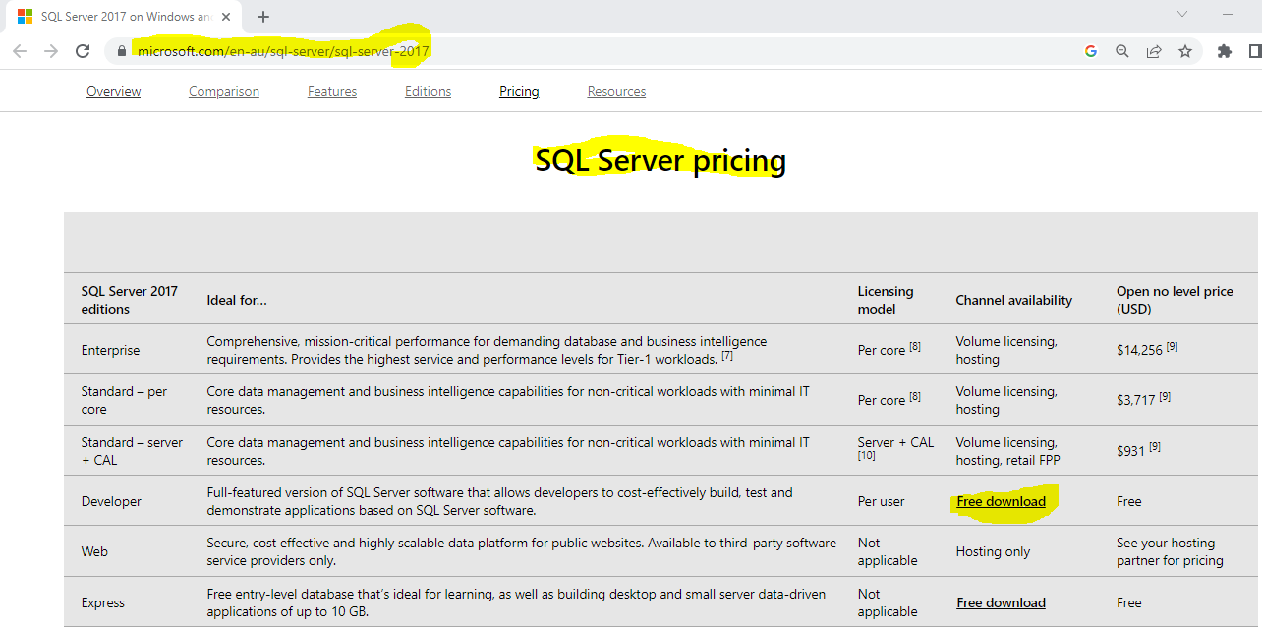

**SQLServer2017-SSEI-Dev.exe**  setup downloaded🡪 double click on this 🡪 Clock on Download Media

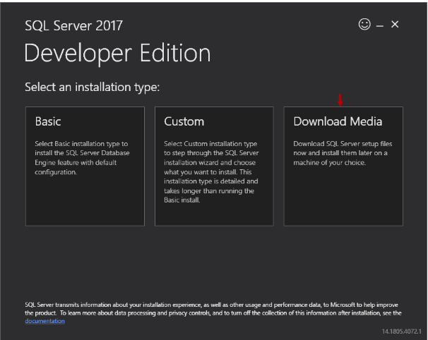

* Select ISO and click on download

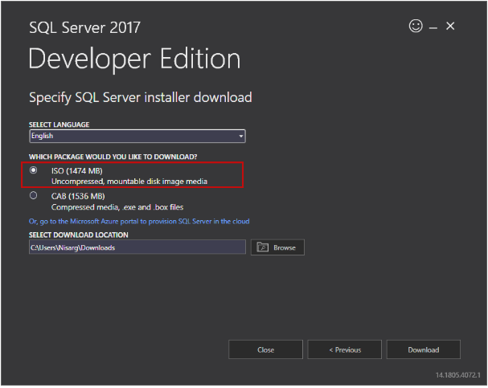

* Double click on setup

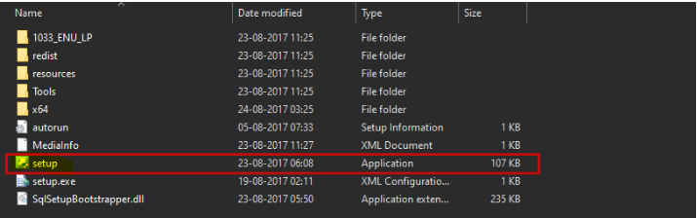

* Click on installation and select stand-alone installation

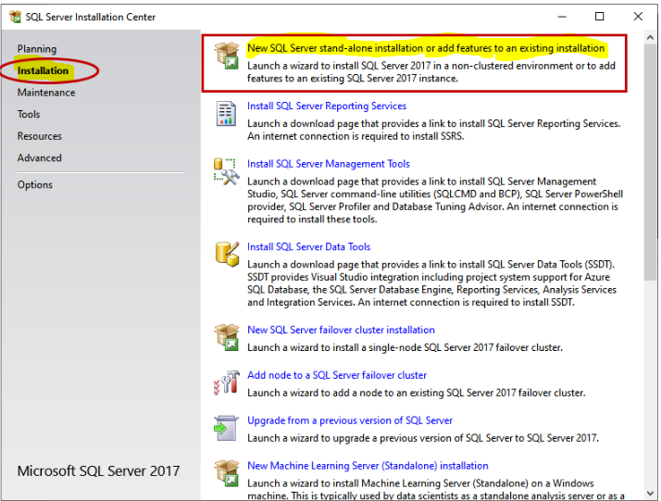

* Select Developer option 🡪 Next

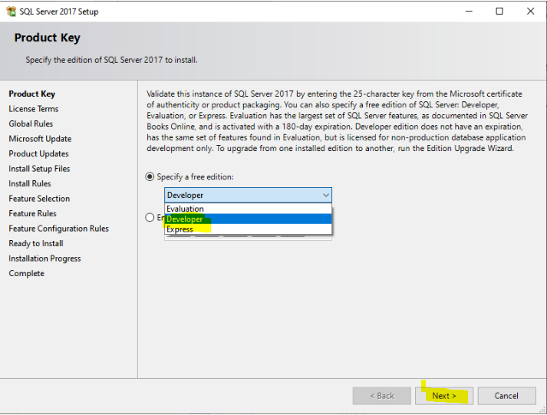

* Select I accept check box and 🡪 Next

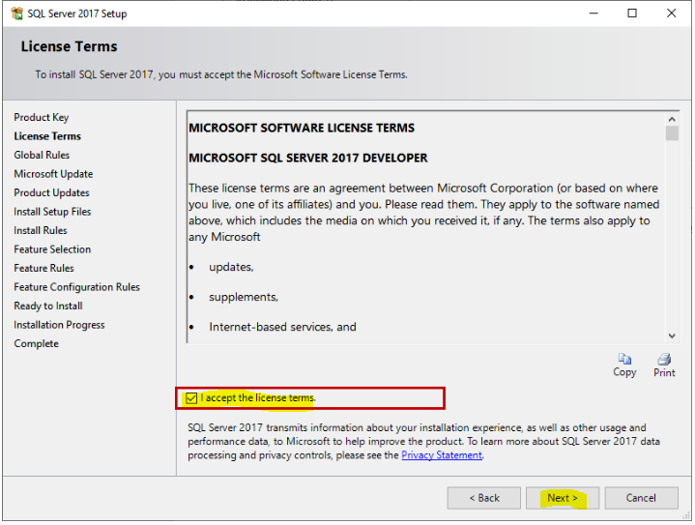

Next

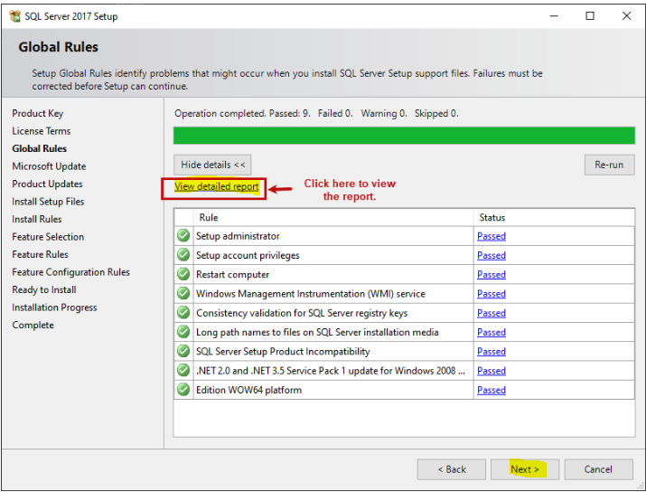

Uncheck this check box and 🡪 Next

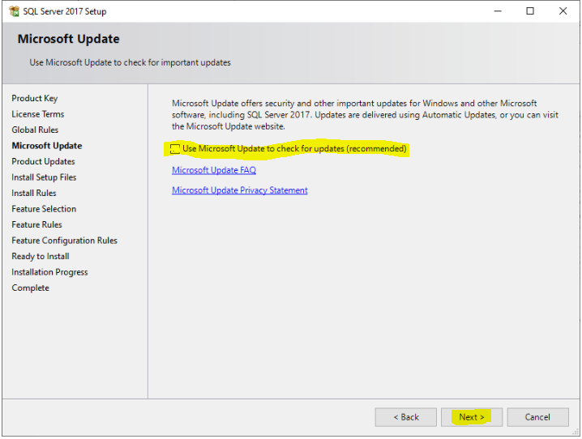

Next

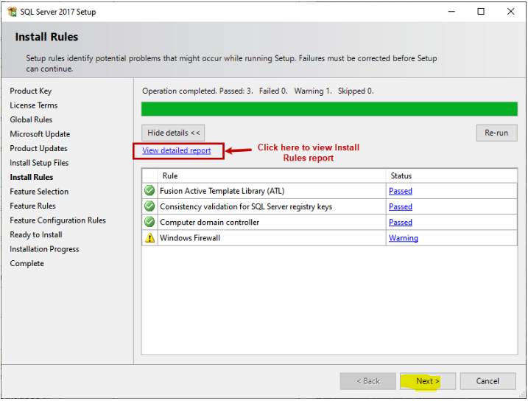

Select All🡪 Next

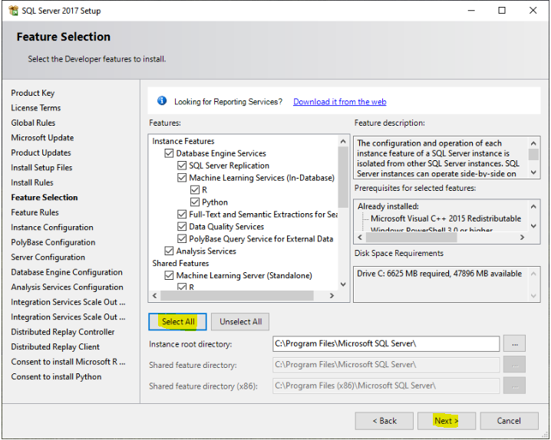

Create Instance Name 🡪 Next

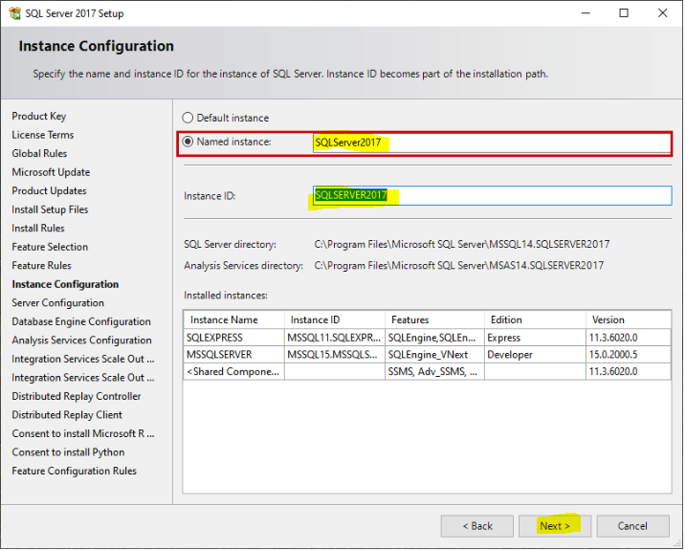

* Select Check Box and 🡪 Next

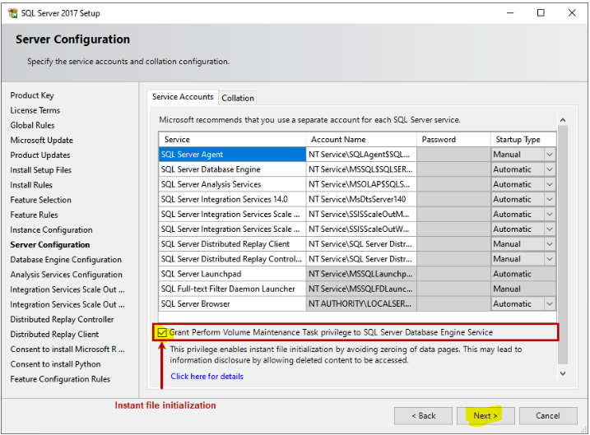

Check collection 🡪 Next

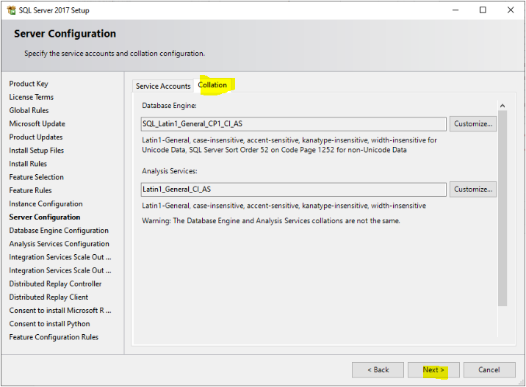

* Create login configuration, Create password and save I your system

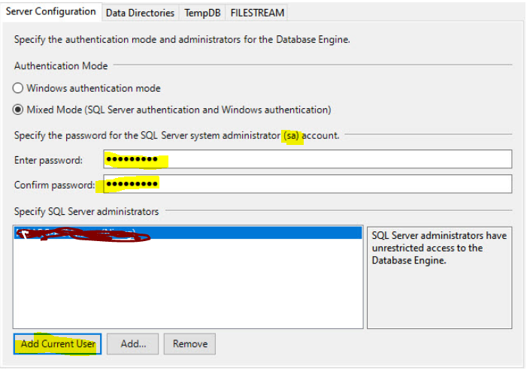

* Click on Data directories, Data directories are not changed

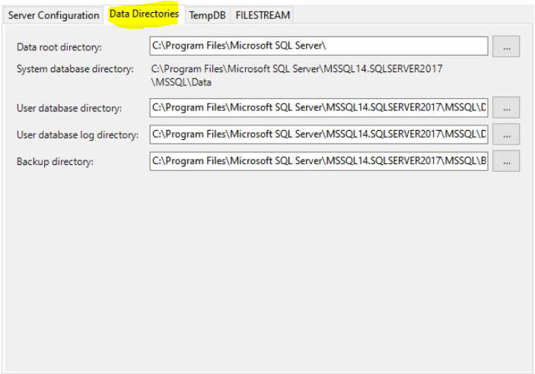

Click on TempDB

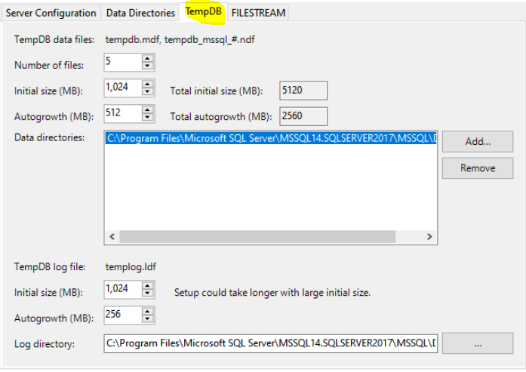

Click on FileStream 🡪 Click Next

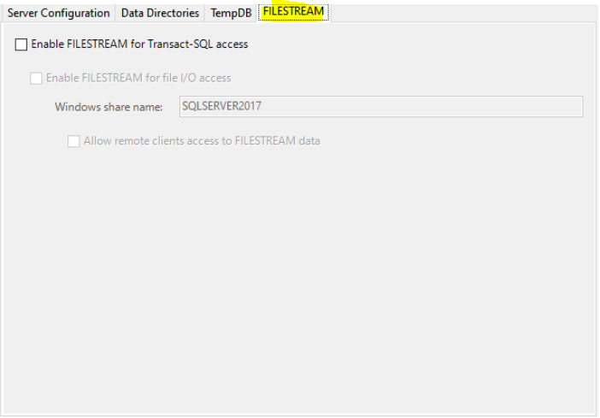

Select Tabular🡪 Click on Add Current User

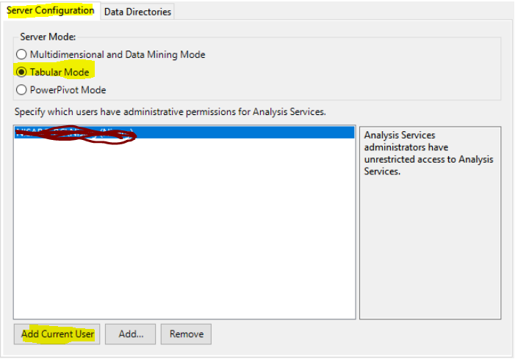

Click on data directories 🡪 Next

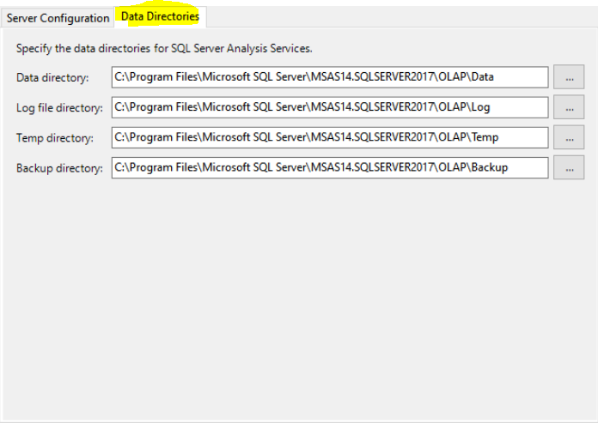

Next

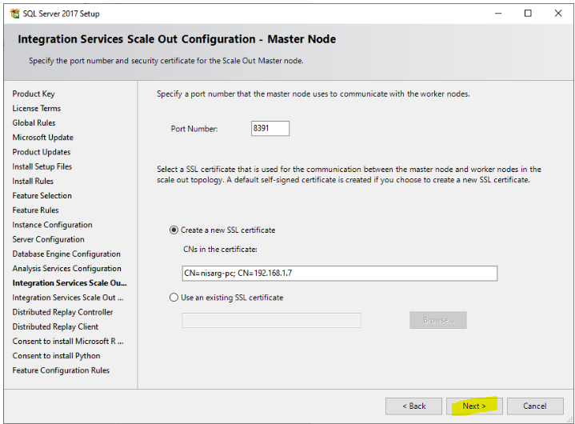

Next

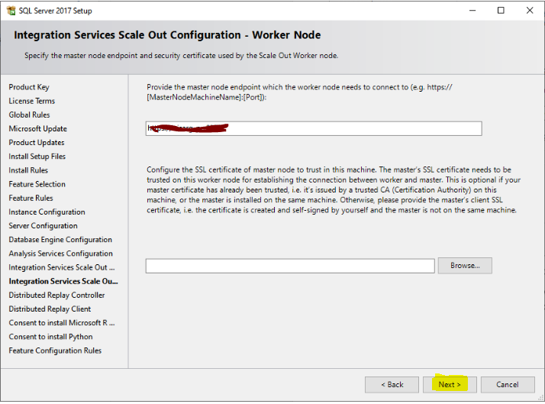

Add Current User🡪 Next

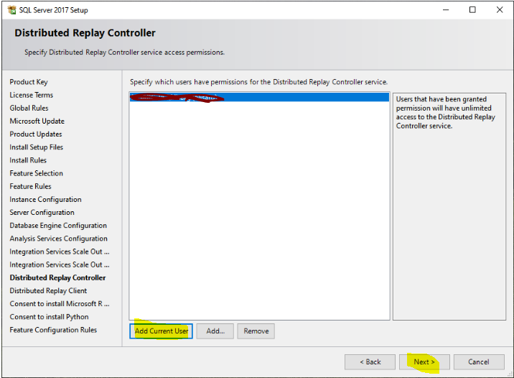

Please provide DRC name and path as per your system and Click Next

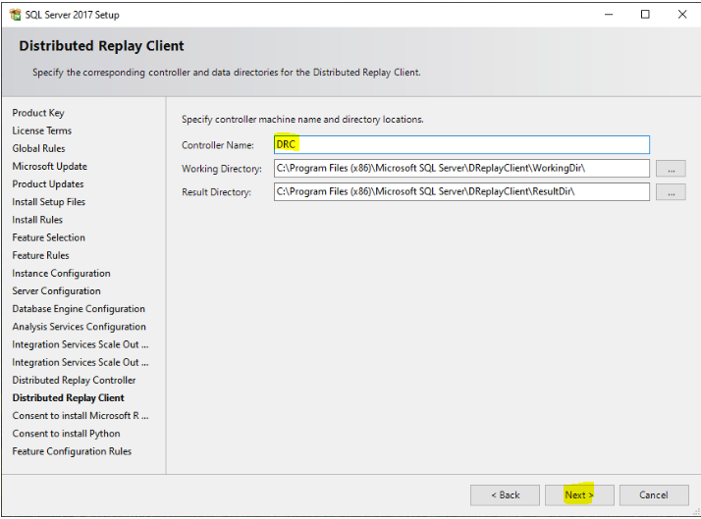

Accept🡪 Next

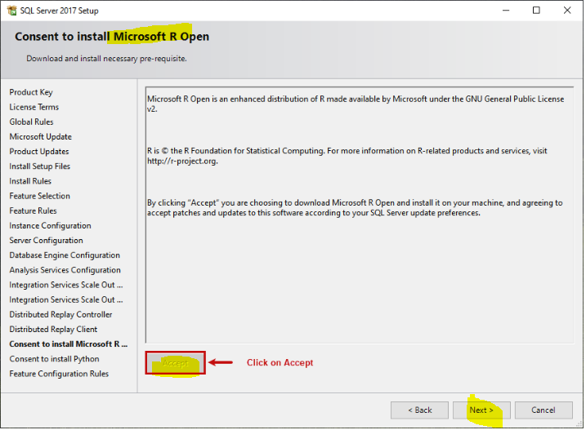

Accept🡪 Next

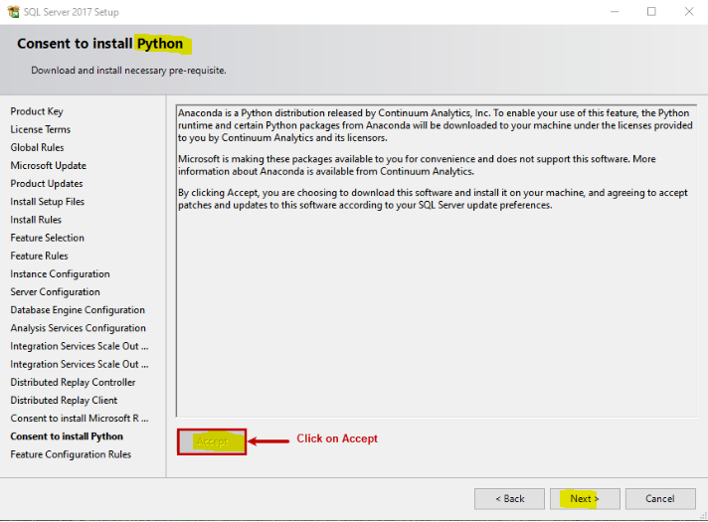

Click on install

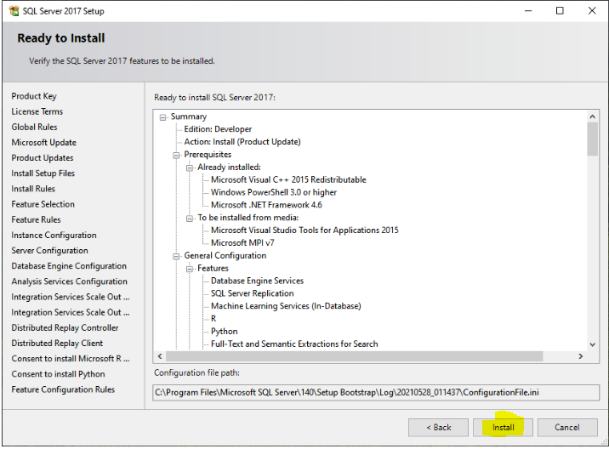

The SQL Server installation process begins.

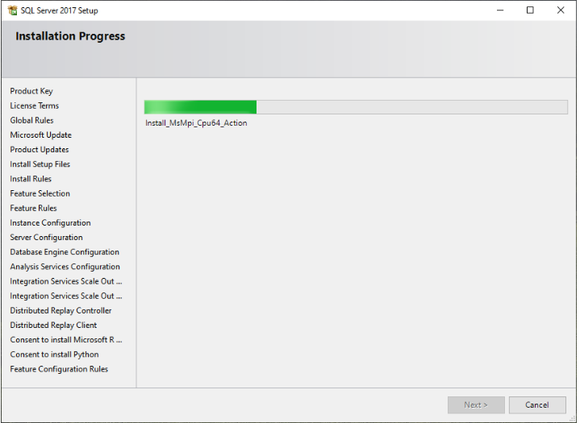

Once installation completes, you can view the list of SQL Server developer edition component that has been successfully installed.

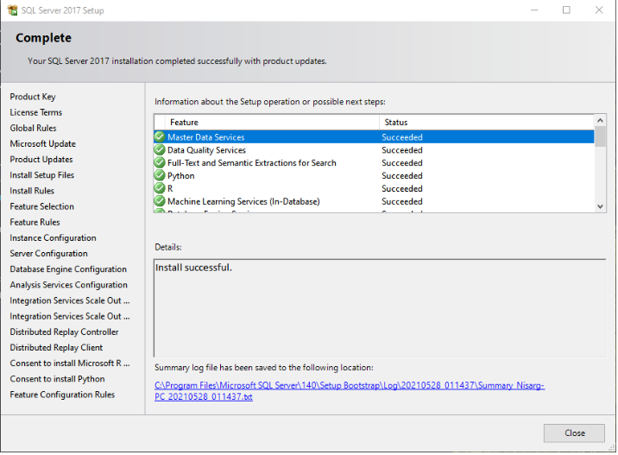

Click on Close and Reboot the server/workstation.

* **Download and Install SSMS (SQL server management Studio)**

[https://learn.microsoft.com/en-us/sql/ssms/release-notes-ssms?view=sql-server-ver16#previous-ssms-releases](https://learn.microsoft.com/en-us/sql/ssms/release-notes-ssms?view=sql-server-ver16%23previous-ssms-releases)

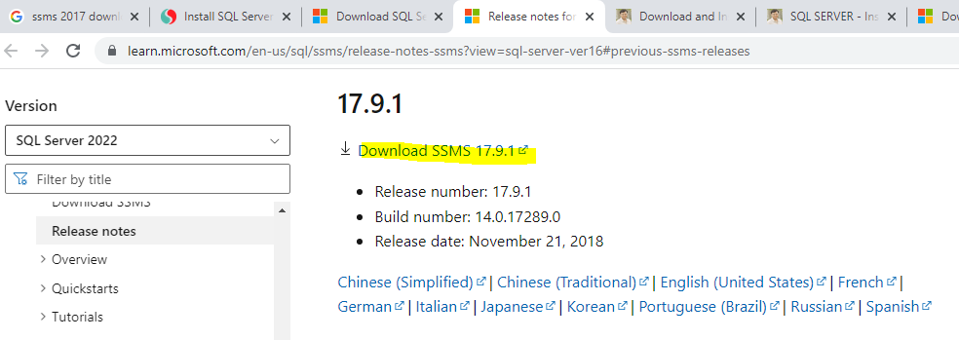

1. Click the **Install** button

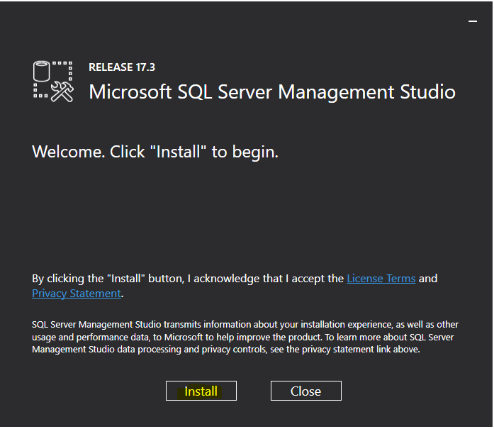

2. Wait for few minutes while the installer sets up the software.

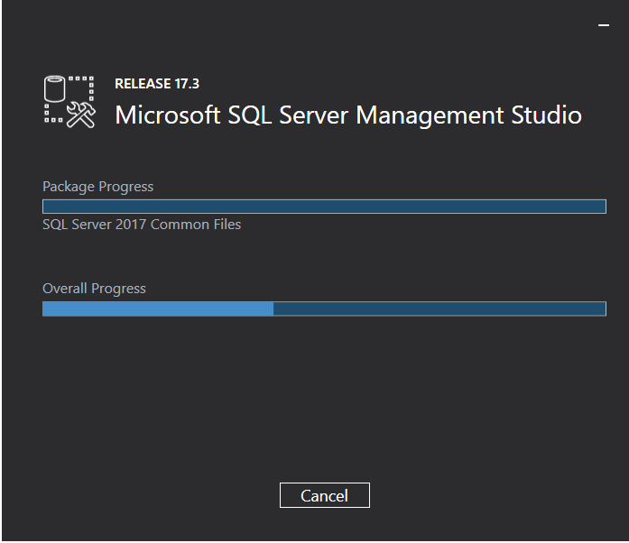

1. Once setup is completed, click the **Close** button

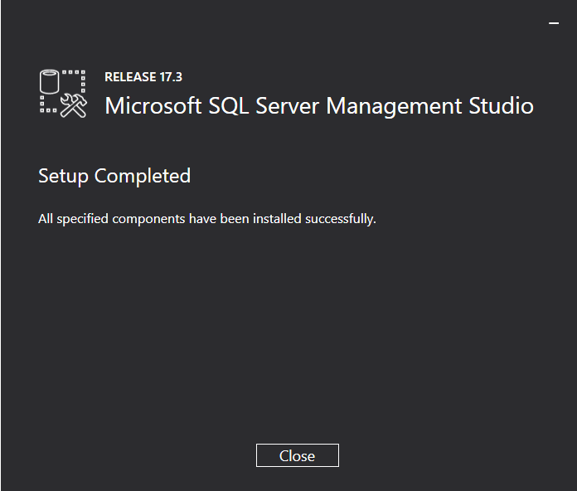

* **Connect to the SQL Server using SSMS**

Launch the Microsoft SQL Server Management Studio from the **Start** menu:

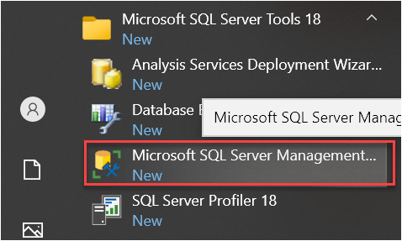

Next, from the **Connect** menu under the **Object Explorer**, choose the **Database Engine**…

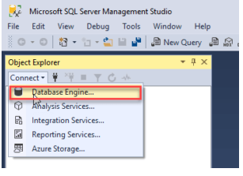

Server Name: - localhost

Drop Down: - SQL Server Authentication

Login: - sa

Password: - password that you entered during the installation

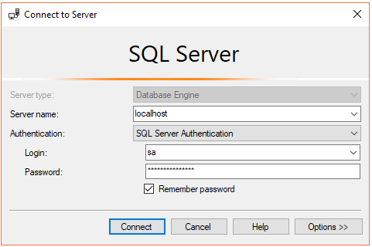

Click **Connect**